October XXth, 2018

To the Editors at Nature Human Behavior,

Please find attached our paper “Any way the brain blows? The nature of decision noise in random exploration.” In this paper we investigate the nature of behavioral variability and its role in exploration. In particular we ask whether exploratory choices are driven by random external stimuli in the world (seemingly irrelevant features in the stimulus, i.e. color of the ink on the menu if you are deciding what to eat) or by random internal neural processes in our brains.

Previous work makes a strong case for both types of randomness being relevant to behavior. %For instance, external, stimulus-driven noise is thought to be a much greater source of choice variability in perceptual decisions than internal noise (Brunton et al 2013). Conversely, neural noise is thought to drive exploratory singing behavior in song birds and the generation of this internal noise has been linked to specific neural structures. (Aston-Jones et al 2005).% However, it’s still disputable which noise is dominant in driving exploration, and the contribution of both external and internal decision noise has not been quantified. By controlling the external stimuli and letting people make decisions in repeated identical scenarios using an adapted version of the horizon task (Wilson et al 2014), we were able to statistically distinguish internally-driven and externally-driven decision noise by assessing to what degree human participants make consistent decisions. If noise is purely externally driven, then people should make identical choices both times in repeated scenarios. However, if noise is purely internally driven, then people should in principal treat the two decisions independently. By looking at the extent to which people make inconsistent choices, we were able to show the existence of both internal and external noise in driving exploration. In addition, we showed behaviorally that people actively adapt the level of internal decision noise to time horizon in the task.

Moreover, we were able to quantify the level of both external and internal decision noise from behavior using a hierarchical Bayesian inference model which accounts for how internal and external noises drive exploration differently. We showed that both external and internal noise drives exploration, but internal noise is what’s really dominant.

By showing that internal decision noise dominates driving random exploration, our paper sheds light on the cognitive mechanisms underlying the randomness in exploration and connects it to the broader literature on behavioral variability, exploration and decision making. As such, we believe this paper will be of wide interest to readers of Nature Human Behavior.

Sincerely,

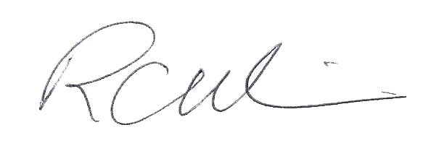

Robert Wilson, Ph.D.